23AI2003 –Artificial Intelligence for Web Development Lab
URK23CS5003

Ex. No: 2 | Styling Online Event Registration & Promotional Portal Using CSS/ Advanced CSS

Aim

To design and enhance the appearance of an Online Event Registration and Promotional Portal using CSS and Advanced CSS techniques in order to create an attractive, responsive, and user-friendly web interface.

Description

In this experiment, CSS and Advanced CSS concepts are applied to improve the overall look and usability of an Online Event Registration and Promotional Portal. Various styling techniques such as layout design, font styling, color combinations, spacing, alignment, and background customization are implemented to structure the web pages effectively. Advanced features like Flexbox, Grid, transitions, animations, and media queries are used to create responsive and interactive web pages that adapt to different screen sizes. This experiment helps in understanding how proper styling enhances user experience, improves accessibility, and gives a professional appearance to web applications.

Code
<!DOCTYPE html>
<html lang="en">
<head>
<meta charset="UTF-8">
<title>Music Concert Registration - Styled</title>
<meta name="viewport" content="width=device-width, initial-scale=1.0">
<!-- External CSS Linking -->
<link rel="stylesheet" href="style.css">
</head>
<body>

<header>
<h1>Live Music Concert 2026 </h1>
<p>Experience the Rhythm of Life!</p>
</header>

<div class="container">

<!-- Media Section -->
<div class="media-section">

<img src="banner.png" alt="Music Concert Banner">

<h3>Promo Video</h3>
<video controls>
<source src="promotional.mp4" type="video/mp4">
</video>

<h3>Intro Music</h3>
<audio controls>
<source src="intro.mp3" type="audio/mpeg">
</audio>

</div>

<!-- Form Section -->
<div class="form-section">
<h2>Register Now</h2>
<form>
<input type="text" placeholder="Full Name" required>
<input type="email" placeholder="Email Address" required>
<input type="date" required>
<div class="radio-group">

<label><input type="radio" name="gender" required> Male</label>
<label><input type="radio" name="gender"> Female</label>
<label><input type="radio" name="gender"> Other</label>
</div>
<select required>
<option value="">Select Ticket Type</option>
<option>General</option>
<option>VIP</option>
<option>Backstage</option>
</select>

<textarea placeholder="Additional Comments"></textarea>

<input type="file" required>

<button type="submit">Register</button>
</form>
</div>
</div>
</body>
</html>

Style.css code
/* Page Styling */
body {
font-family: Arial, sans-serif;
margin: 0;
background: linear-gradient(to right, #1e3c72, #2a5298);
color: white;
}

/* Header */
header {
text-align: center;
padding: 20px;
background-color: rgba(0,0,0,0.5);
}
/* Main Container using Flexbox */
.container {
display: flex;
justify-content: space-around;
align-items: flex-start;
padding: 30px;
gap: 30px;
}
/* Media Section */
.media-section img {
width: 100%;
max-width: 500px;
border-radius: 10px;
}

video, audio {
width: 100%;
max-width: 500px;
margin-top: 10px;
}
/* Form Section */
.form-section {
background: white;
color: black;
padding: 20px;

border-radius: 10px;
width: 350px;
}
/* Inputs */
form input,
form select,
form textarea {
width: 100%;
padding: 10px;
margin: 8px 0;
border-radius: 5px;
border: 1px solid #ccc;
transition: 0.3s;
}
/* Input Focus Transition */
form input:focus,
form select:focus,
form textarea:focus {
border-color: #2a5298;
box-shadow: 0 0 8px #2a5298;
}
/* Button Styling */
button {
width: 100%;
padding: 10px;
background-color: #1e3c72;
color: white;
border: none;
border-radius: 5px;
cursor: pointer;
transition: 0.3s;

}
/* Button Hover Transition */
button:hover {
background-color: #2a5298;
transform: scale(1.05);
}
/* Media Queries - Tablet */
@media (max-width: 768px) {
.container {
flex-direction: column;
align-items: center;
}
}
/* Media Queries - Mobile */
@media (max-width: 480px) {
header h1 {
font-size: 20px;
}

.form-section {
width: 90%;
}
}

Input & Output
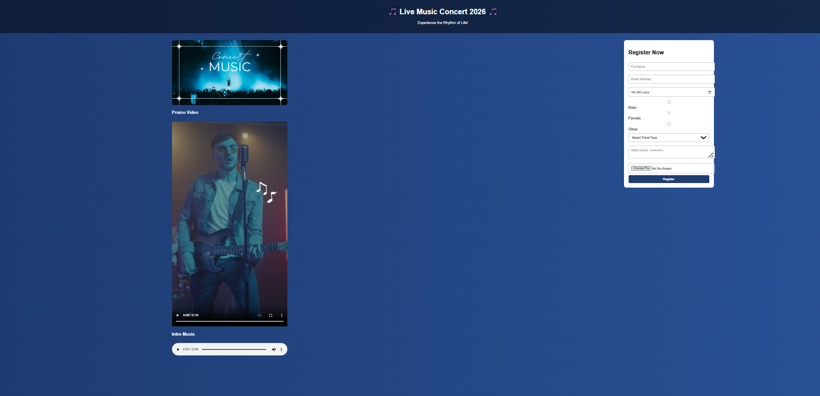

Result
The experiment was successfully completed.

